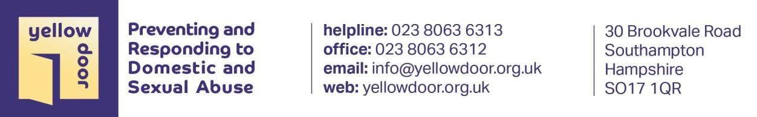

YELLOW DOORS CURRENT SERVICES

Yellow Door offers support to adults, children, young people and families across Southampton, Western Hampshire and the Isle of Wight, aiming to prevent and relieve distress resulting from abuse and interpersonal harm through a range of services and interventions.

Helpline
Our helpline is available for adults and young people affected by sexual abuse as well as family members, friends and professionals every Wednesday 4 – 7pm.

Adult Therapeutic Services
This service offers face-to-face weekly counselling sessions to men and women who have at any time experienced sexual violence or abuse. Alongside this the following groups are provided:-

Emotional Coping Skills Group
A psycho-educational group offering skills development to those who may be struggling to manage strong feelings and emotions as a consequence of abusive experiences.

Safer Relationships Group
This therapeutic group is for women who have experienced domestic abuse and would like to explore ways of developing healthier and safer relationships.

‘Then and Now’ Group
This group has been developed for adults who experienced childhood sexual abuse seeking to explore their thoughts and feelings in a group setting.

Pattern Changing
A 12-week educational programme focused on recognising the impact of domestic abuse, understanding the categories of abuse, identifying and expressing feelings associated with fear, grief and guilt, applying assertiveness techniques, making decisions, setting goals and building healthy relationships. The objective of the course is to break the cycle of ongoing abusive relationships and promote participants to develop positive patterns of their own choosing

Pattern Changing for Young Women
A 6-week educational programme for women aged 16-19 years. Focussed on recognising domestic abuse, building assertiveness techniques and managing feelings.

Children & Young People’s Therapeutic Services
This service provides specialist therapeutic help to children and young people affected by sexual or domestic abuse. This also includes a specialist therapist working with under 11’s and an Outreach service for those who find it difficult or not appropriate to access our centre. This service offers face-to-face weekly counselling sessions as well as the following groups:-

Yellow Door (Solent) is a Company Limited by Guarantee (No. 5486084) and a Charity (No. 1111753) registered in England and Wales.

Creative Arts Group
Uses creative and art therapies to help young people who have experienced sexual
abuse explore feelings and develop healthier coping mechanisms.

Bright Stars
A psycho-educational group for young people who have experienced and/or witnessed domestic abuse that maintains a focus on managing emotions and staying safe in relationships.

Pyscho-Education Group
A short term young person’s intervention providing information on trauma and its
effects and ways to manage/cope with the impact.

Gender Identity Therapeutic Group
Our therapeutic group for young people aged 12 -18 who are struggling with Gender Dysphoria gives time and space to improving wellbeing, decreasing isolation and considering the options available to them in creative and interactive weekly sessions.

Safe, Talk, Thrive
A 10-week programme in primary schools for children and their non-abusing parent who have experienced domestic abuse. Both parent and child will engage with the ACES Recovery Toolkit for Adults and CYP.

Surestart Special
An 8-week programme for children aged 3-5 years and their Mothers/carer who have been exposed to domestic abuse.
Mothers complete You & Me, Mum course, a self-help programme which aims to empower, support and develop further understanding of the role of a mother, in addressing the needs of children and young people who have lived with domestic violence. The children will engage with group Thera-Play sessions with a qualified Play Therapist. During these sessions children will be encouraged to explore their feelings and communicate through play.

Family Therapy & Parenting Support
We work with families to increase awareness of risk and prevent repeat harm as well as manage the emotional impact of domestic or sexual abuse. In Family Therapy sessions or Parenting Support we work to develop shared understandings, strengthen communication and build trusting relationships.

Independent Sexual Violence Advisors (ISVA)
This service specialises in practical, non-judgmental and compassionate support for those engaging with the criminal justice system following experiences of assault. They work to ensure that service users receive the most appropriate help and support available throughout these processes.

The STAR Project
An award winning Healthy Relationships education programme delivered to all Southampton Secondary Schools, some primary schools and other youth/community settings tackling topics such as cyberbullying, sexting, sexual exploitation, on-line risk & substance misuse.

Yellow Door (Solent) is a Company Limited by Guarantee (No. 5486084) and a Charity (No. 1111753) registered in England and Wales.

Diversity & Inclusion Advocacy Service
Offers tailored, needs-led help to those who may otherwise face language, communication, physical or financial barriers to accessing domestic or sexual abuse services.

PIPPA Helpline
Run in conjunction with the Independent Domestic Abuse Advocates as part of the Prevention, Intervention and Public Protection Alliance (PIPPA). Line is open five days a week acting as a single point of contact for the public and professionals, offering advice and information to improve safety as well as signposting to specialist support services.

August 2019

Yellow Door (Solent) is a Company Limited by Guarantee (No. 5486084) and a Charity (No. 1111753) registered in England and Wales

